**Virtual Machine USING AZURE**

<https://docs.microsoft.com/en-us/learn/modules/create-windows-virtual-machine-in-azure/2-create-a-windows-virtual-machine>

Before Installation of VM on Azure first to activate sandbox

Activate sandbox

<https://docs.microsoft.com/en-us/learn/modules/create-windows-virtual-machine-in-azure/3-exercise-create-a-vm>

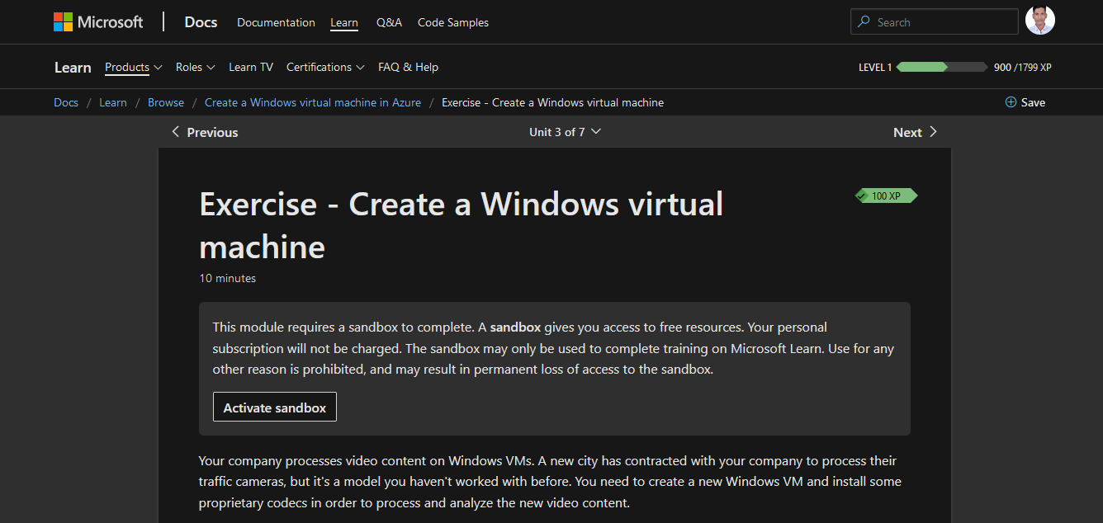

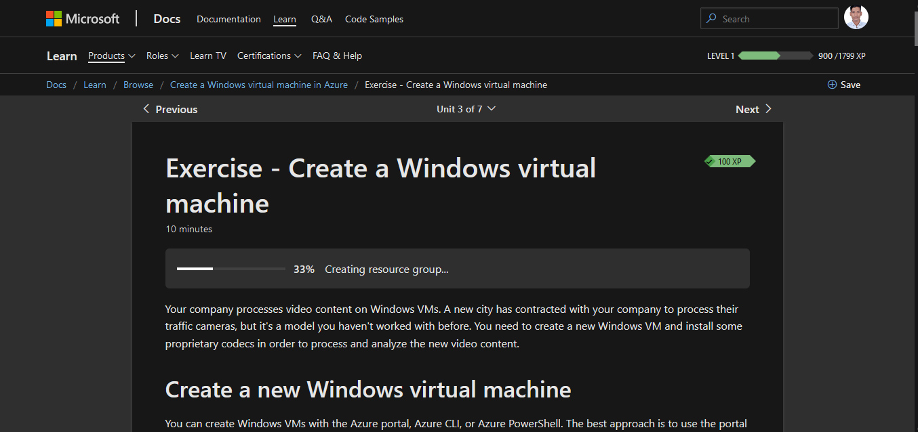

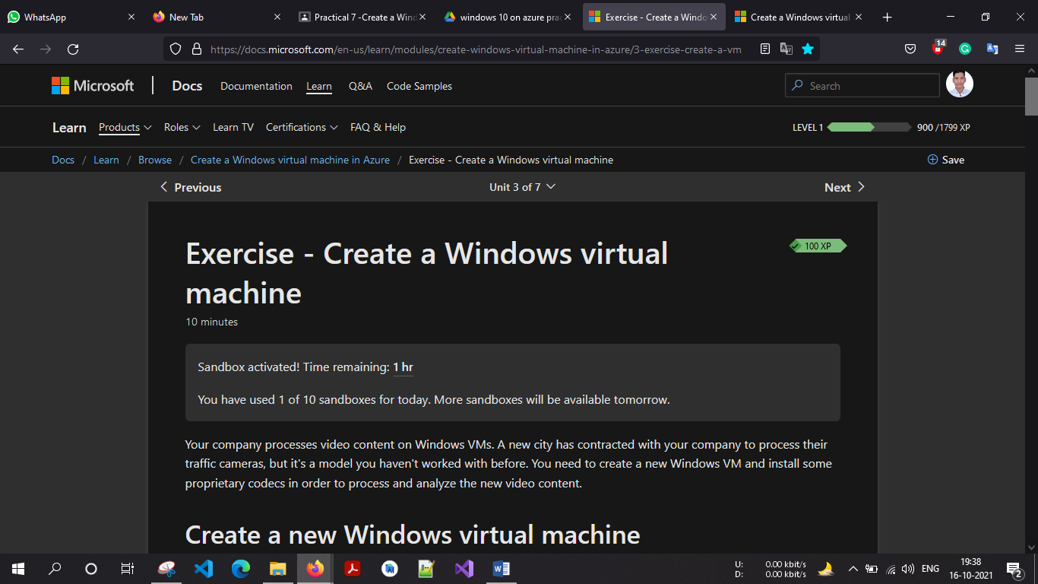

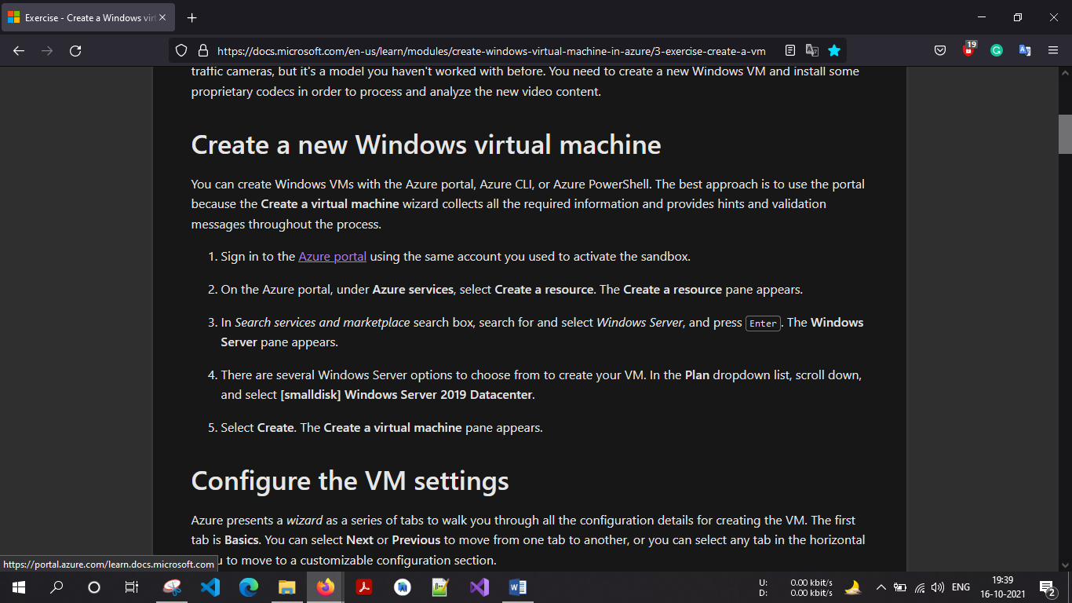

<https://portal.azure.com/#home>

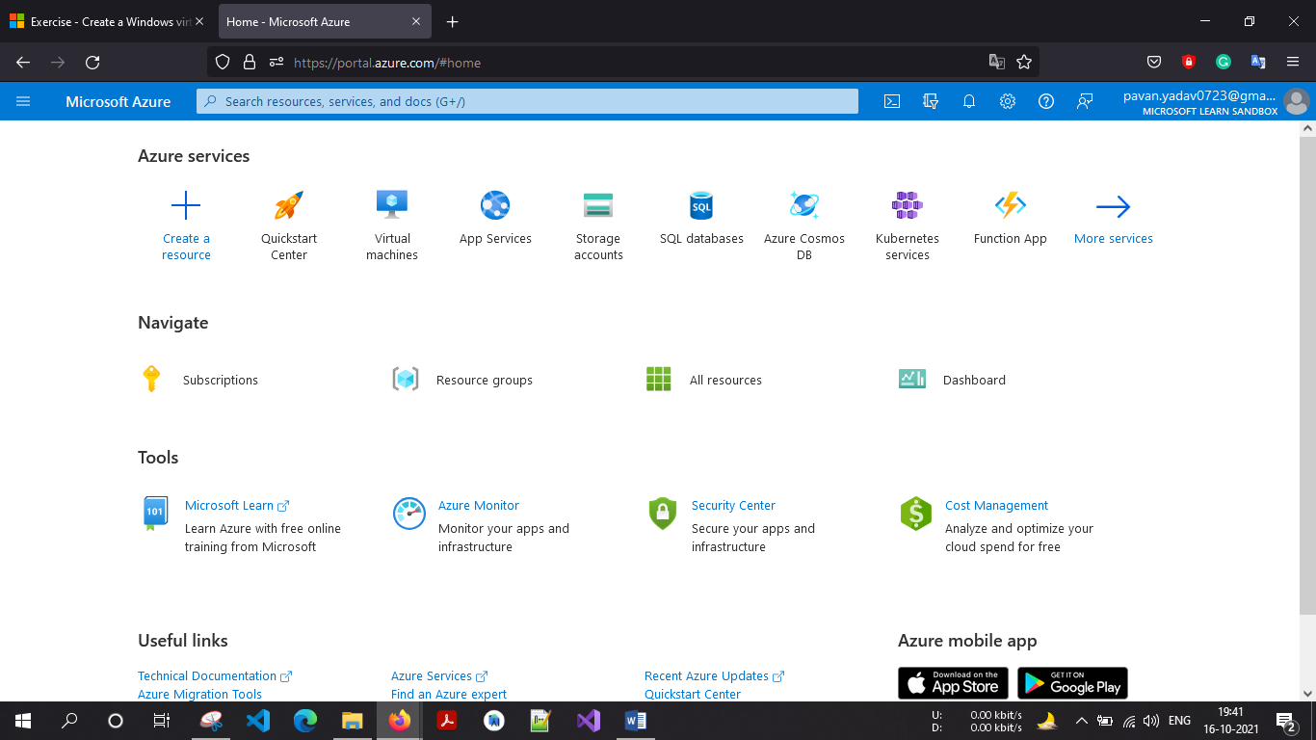

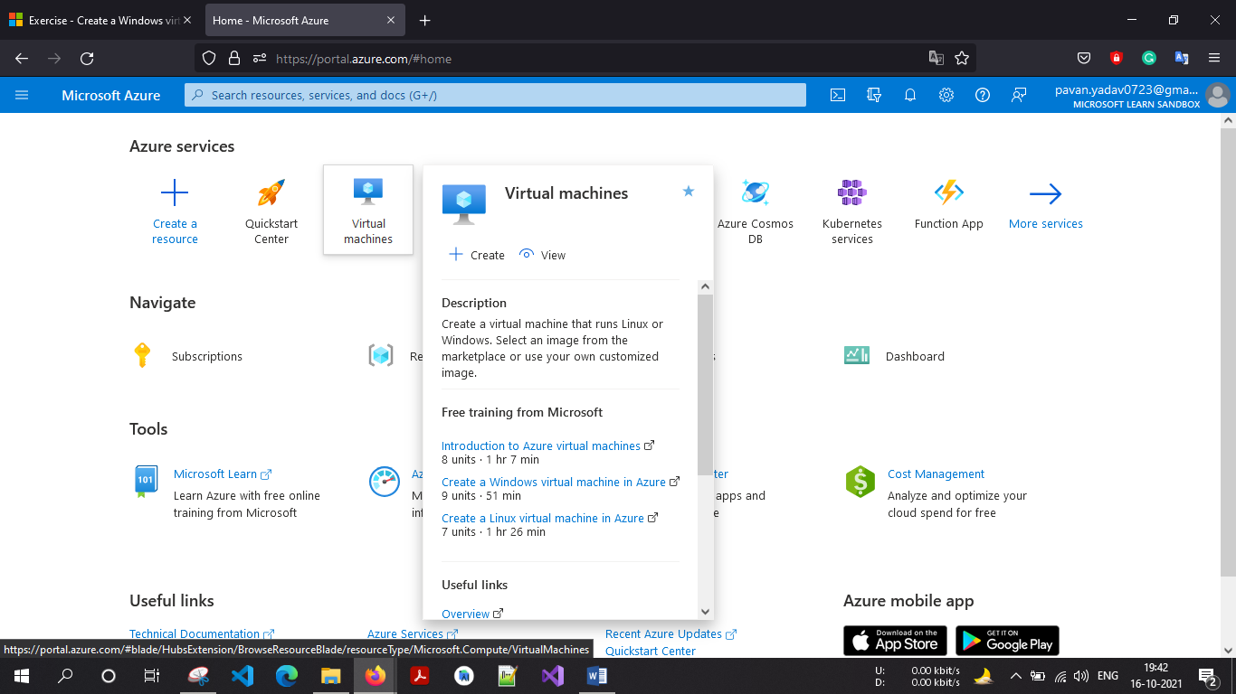

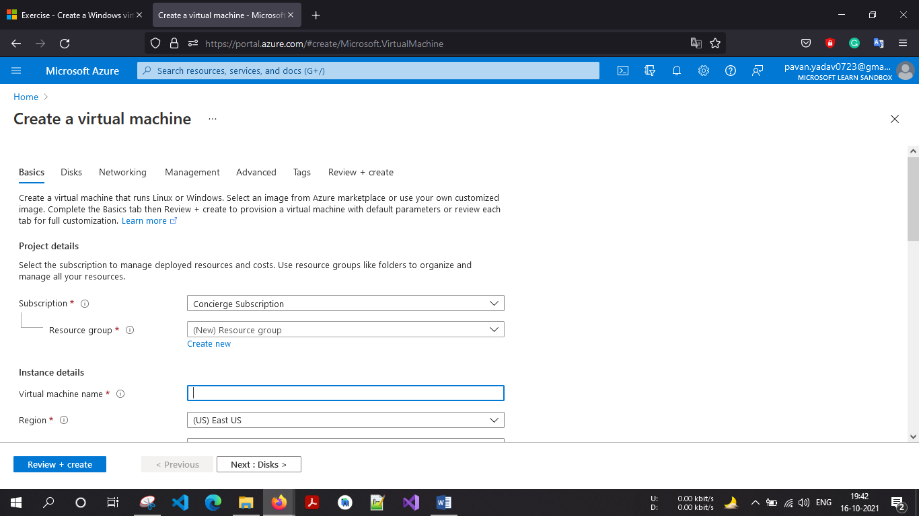

VM Name : **PracticeWindowsOS**

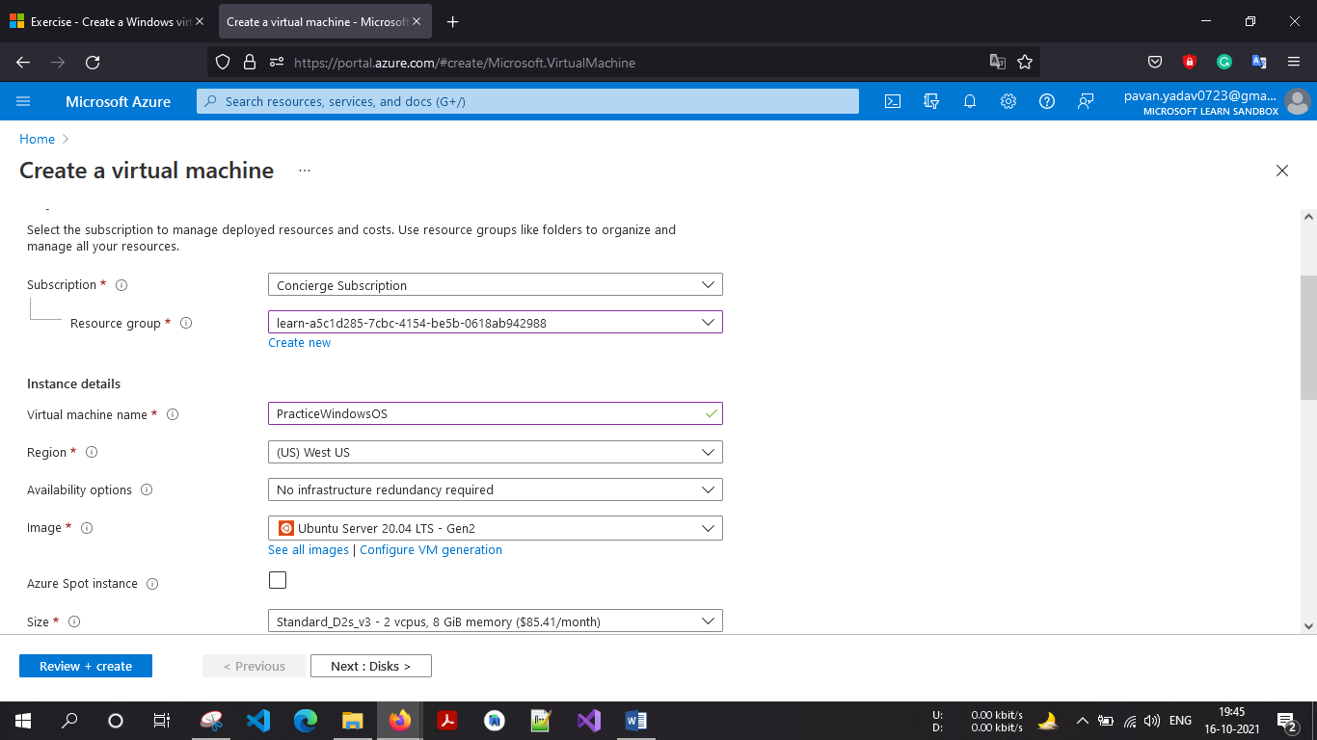

Select Image: Windows 10 Pro

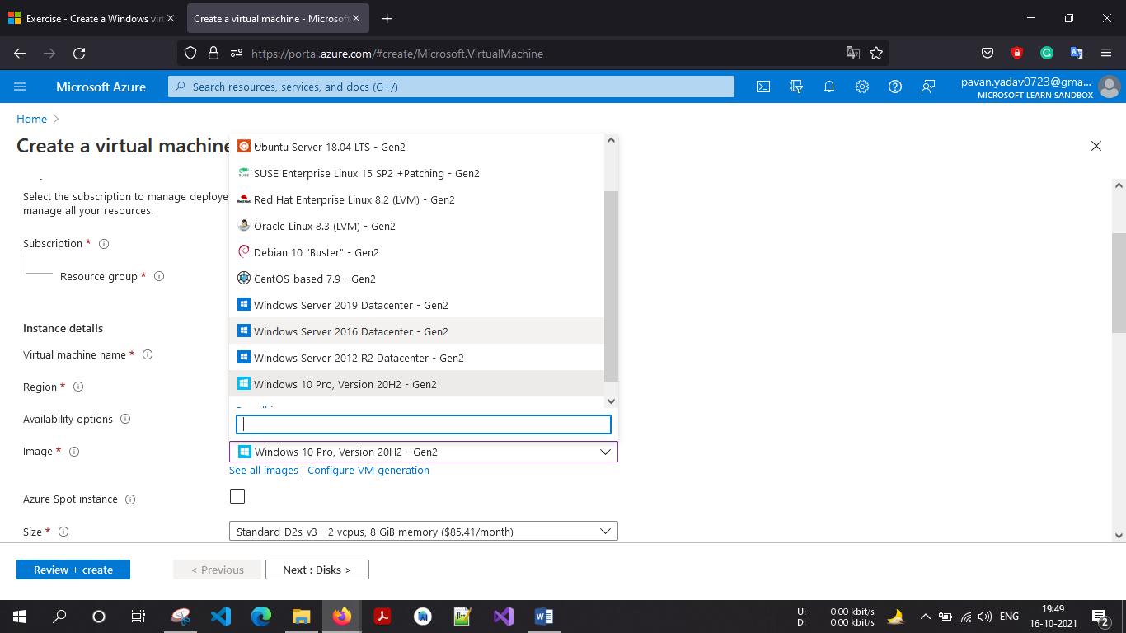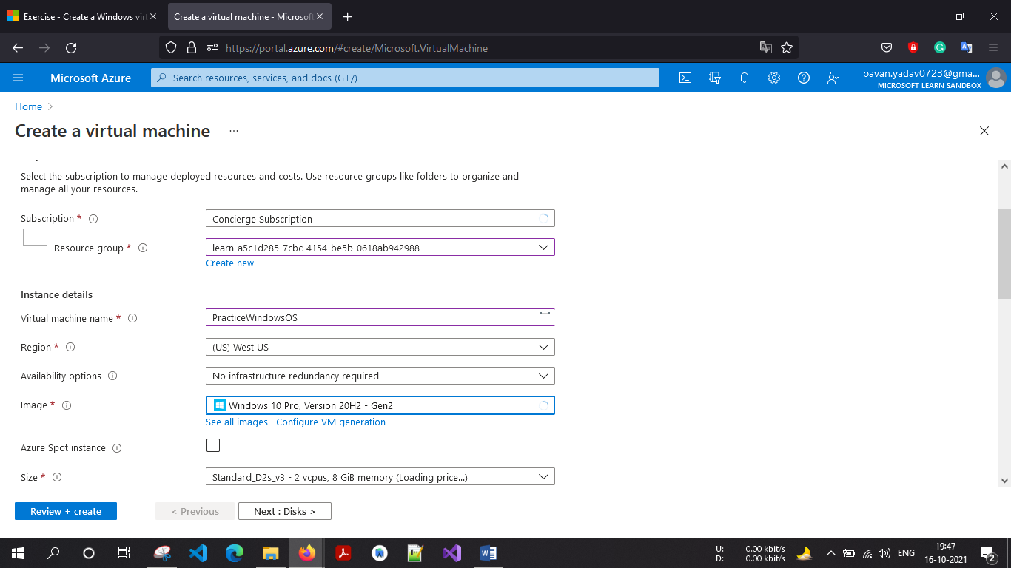

Create a Username & Password:

I was created my

Username : pavanK0723 and

Password: P@v@nK********* (The value must be between 12 and 123 characters long.)

